Highlights and glitter

Laura went into a stationery shop. Her dad gave her £3 to spend.

She wanted to buy some highlighters costing 20p each and glitter pens at 30p each.

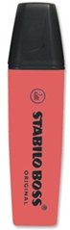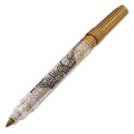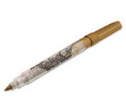

She bought twice as many glitter pens as highlighters.
She was given 60p change.

How many of each did Laura buy?

